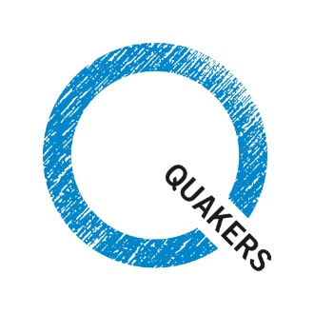
After the election

As the new government settles and new MPs take their seats in Parliament, what can we do to ensure that the voices of local communities are heard in Westminster?

Connect with others in your meeting
Connect with your local community

Keep the relationships going
Welcome your MP or councillors

After the election, one of the most useful things you can do is to make sure you connect with your MP and your community. The actions which we take can help to build the foundations of a hospitable community.

Connect with your local community  Times of change can be opportunities to connect with others – holding conversations and finding common ground.  Your local meeting could:  - Hold an open afternoon and invite your neighbours to visit you for tea and cake.  - Visit your neighbours. Which groups do you work with least? Can you forge new links?  - Do you need a path through this period of political uncertainty? The wider community may feel divided, and your meeting may be either delighted or disappointed. Consider holding a Meeting for Reconciliation and Reflection. It is a safe space in which to express hopes and fears, listening honestly to each other.  (See next page for an example.) | Speak with your representatives  Some meetings have already tried these events, and found they worked for them.  - Invite your new MP to speak to you – either as a small group of Quakers or as a much larger meeting including other local community groups.  - Contact local councillors or other representatives (such as AMs in Wales or MSPs in Scotland.) Can you work together on an issue?  - Join a larger campaign.  (See next page for upcoming campaigning opportunities.)  - Invite staff at Britain Year Meeting to give a talk or run a workshop. Email politics@quaker.org.uk to enquire about a speaker. Think about the subject you’re most interested in.

Use the period after 8 June to encourage good foundations for future relationships.
You know it has been a success if you meet your MP again in the next six months or you build a new relationship with a group in your local community.
What have other meetings done?
Campaign opportunities

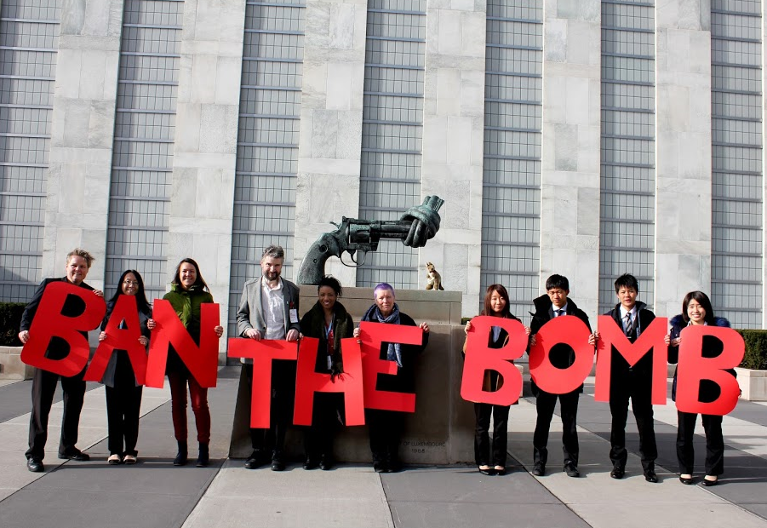

UN Nuclear Weapons Ban Treaty
15 June – 7 July 2017
www.quaker.org.uk/our-work/peace/nuclear-disarmament
Contact:timw@quaker.org.uk

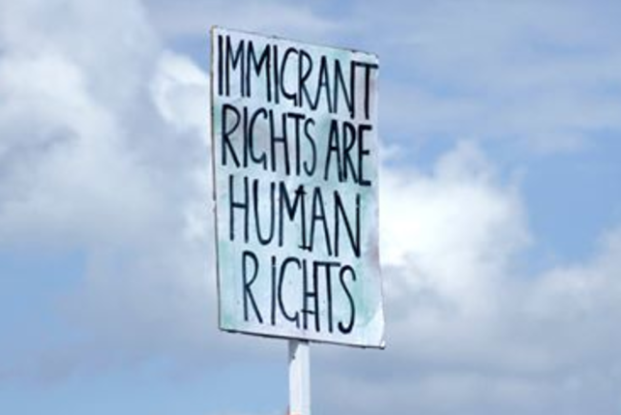

Refugee week
19-25 June 2017
www.quaker.org.uk/migration
Contact: timothyg@quaker.org.uk

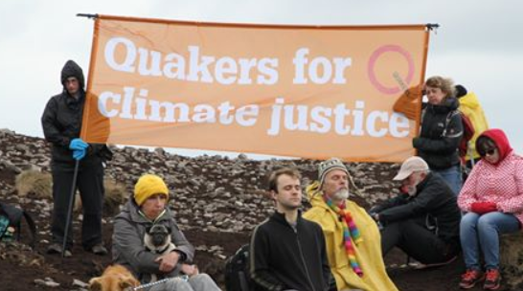

Climate week of action
1-9 July 2017
www.quaker.org.uk/climatejustice
Contact: mayaw@quaker.org.uk

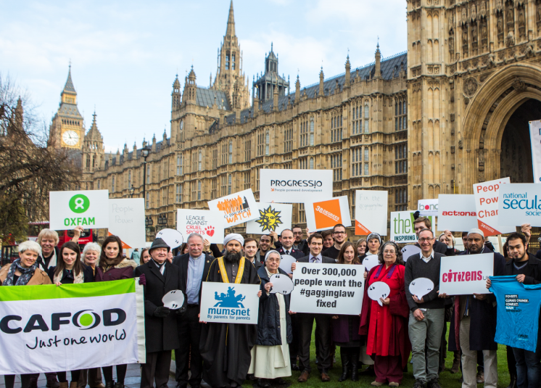

Parliament week
13-19 November 2017
www.ukparliamentweek.org
Contact: jessicam@quaker.org.uk

Could you take inspiration from this events and activities organised by other meetings?
Reflect After the referendum, the Quaker Council for European Affairs organised a Meeting for Reconciliation and Reflection. Rather than being about resolving conflict within a group, this meeting was about individuals reconciling themselves with their own feelings, reflecting on how the result of the referendum had affected them.
Showcase stories Journeymen Theatre, a small touring company, have performed plays in many Meeting Houses. Recent performances include The Bundle, Feeding the Darkness, and Over the Top. www.journeymentheatre.com/
Act together Friends in Kendal and Sedburgh took a pilgrimage, walking 50 miles on a ‘walk for the common good’, in order to consider and raise awareness about the welfare state.
Raise awareness A group of young Quakers cycled from central London to the Atomic Weapons Establishment in Burghfield, near Reading.
Offer shelter The Quaker Meeting House in Tunbridge Wells is being converted into studio flats for homeless people. It is a joint project with Tunbridge Wells Borough Council, the YMCA, and building charity Habitat for Humanity.
Lobby those in power Totnes Quakers travelled to Westminster as part of the Climate Lobby in June 2015.
Host a talk Many staff at Britain Year Meeting give talks or run workshops. Speak to politics@quaker.org.uk, or search on www.quaker.org.uk to contact BYM staff members directly.
Find more examples of what others have done: www.quaker.org.uk/our-work/our-stories

Download resources from the Toolkit for Action: www.quaker.org.uk/toolkit-for-action

Contact Turning the Tide for training for groups taking action: www.turningtide.org.uk

Everyone is welcome at a Quaker meeting.

